**CSC 667: Final Project**

**Backend:**

**JOHN**

**DAISY SUN**

**Franky Dong**

**Frontend:**

**SAM**

**JIA NAN MAI**

**Aaditya Chokshi**

**Proposal:**

A yelp like app called **Help!**, which shows all the reviews 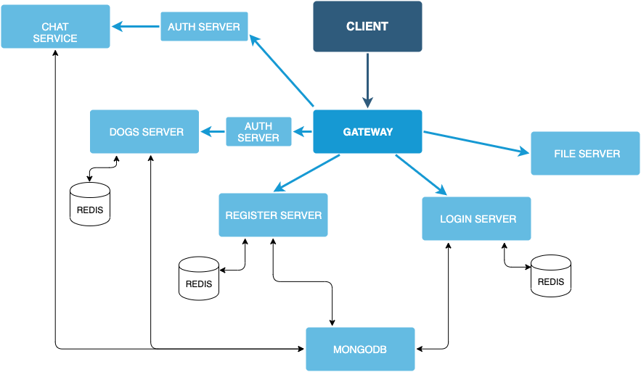**made for restaurants (for now.). A user can create a business account or a normal account. The user account can create new business and look at the reviews. The user account can select a restaurant from the dropdown and write a review for the restaurant. Any real-time updates will be shown to all users.**

**UI Mockups:**

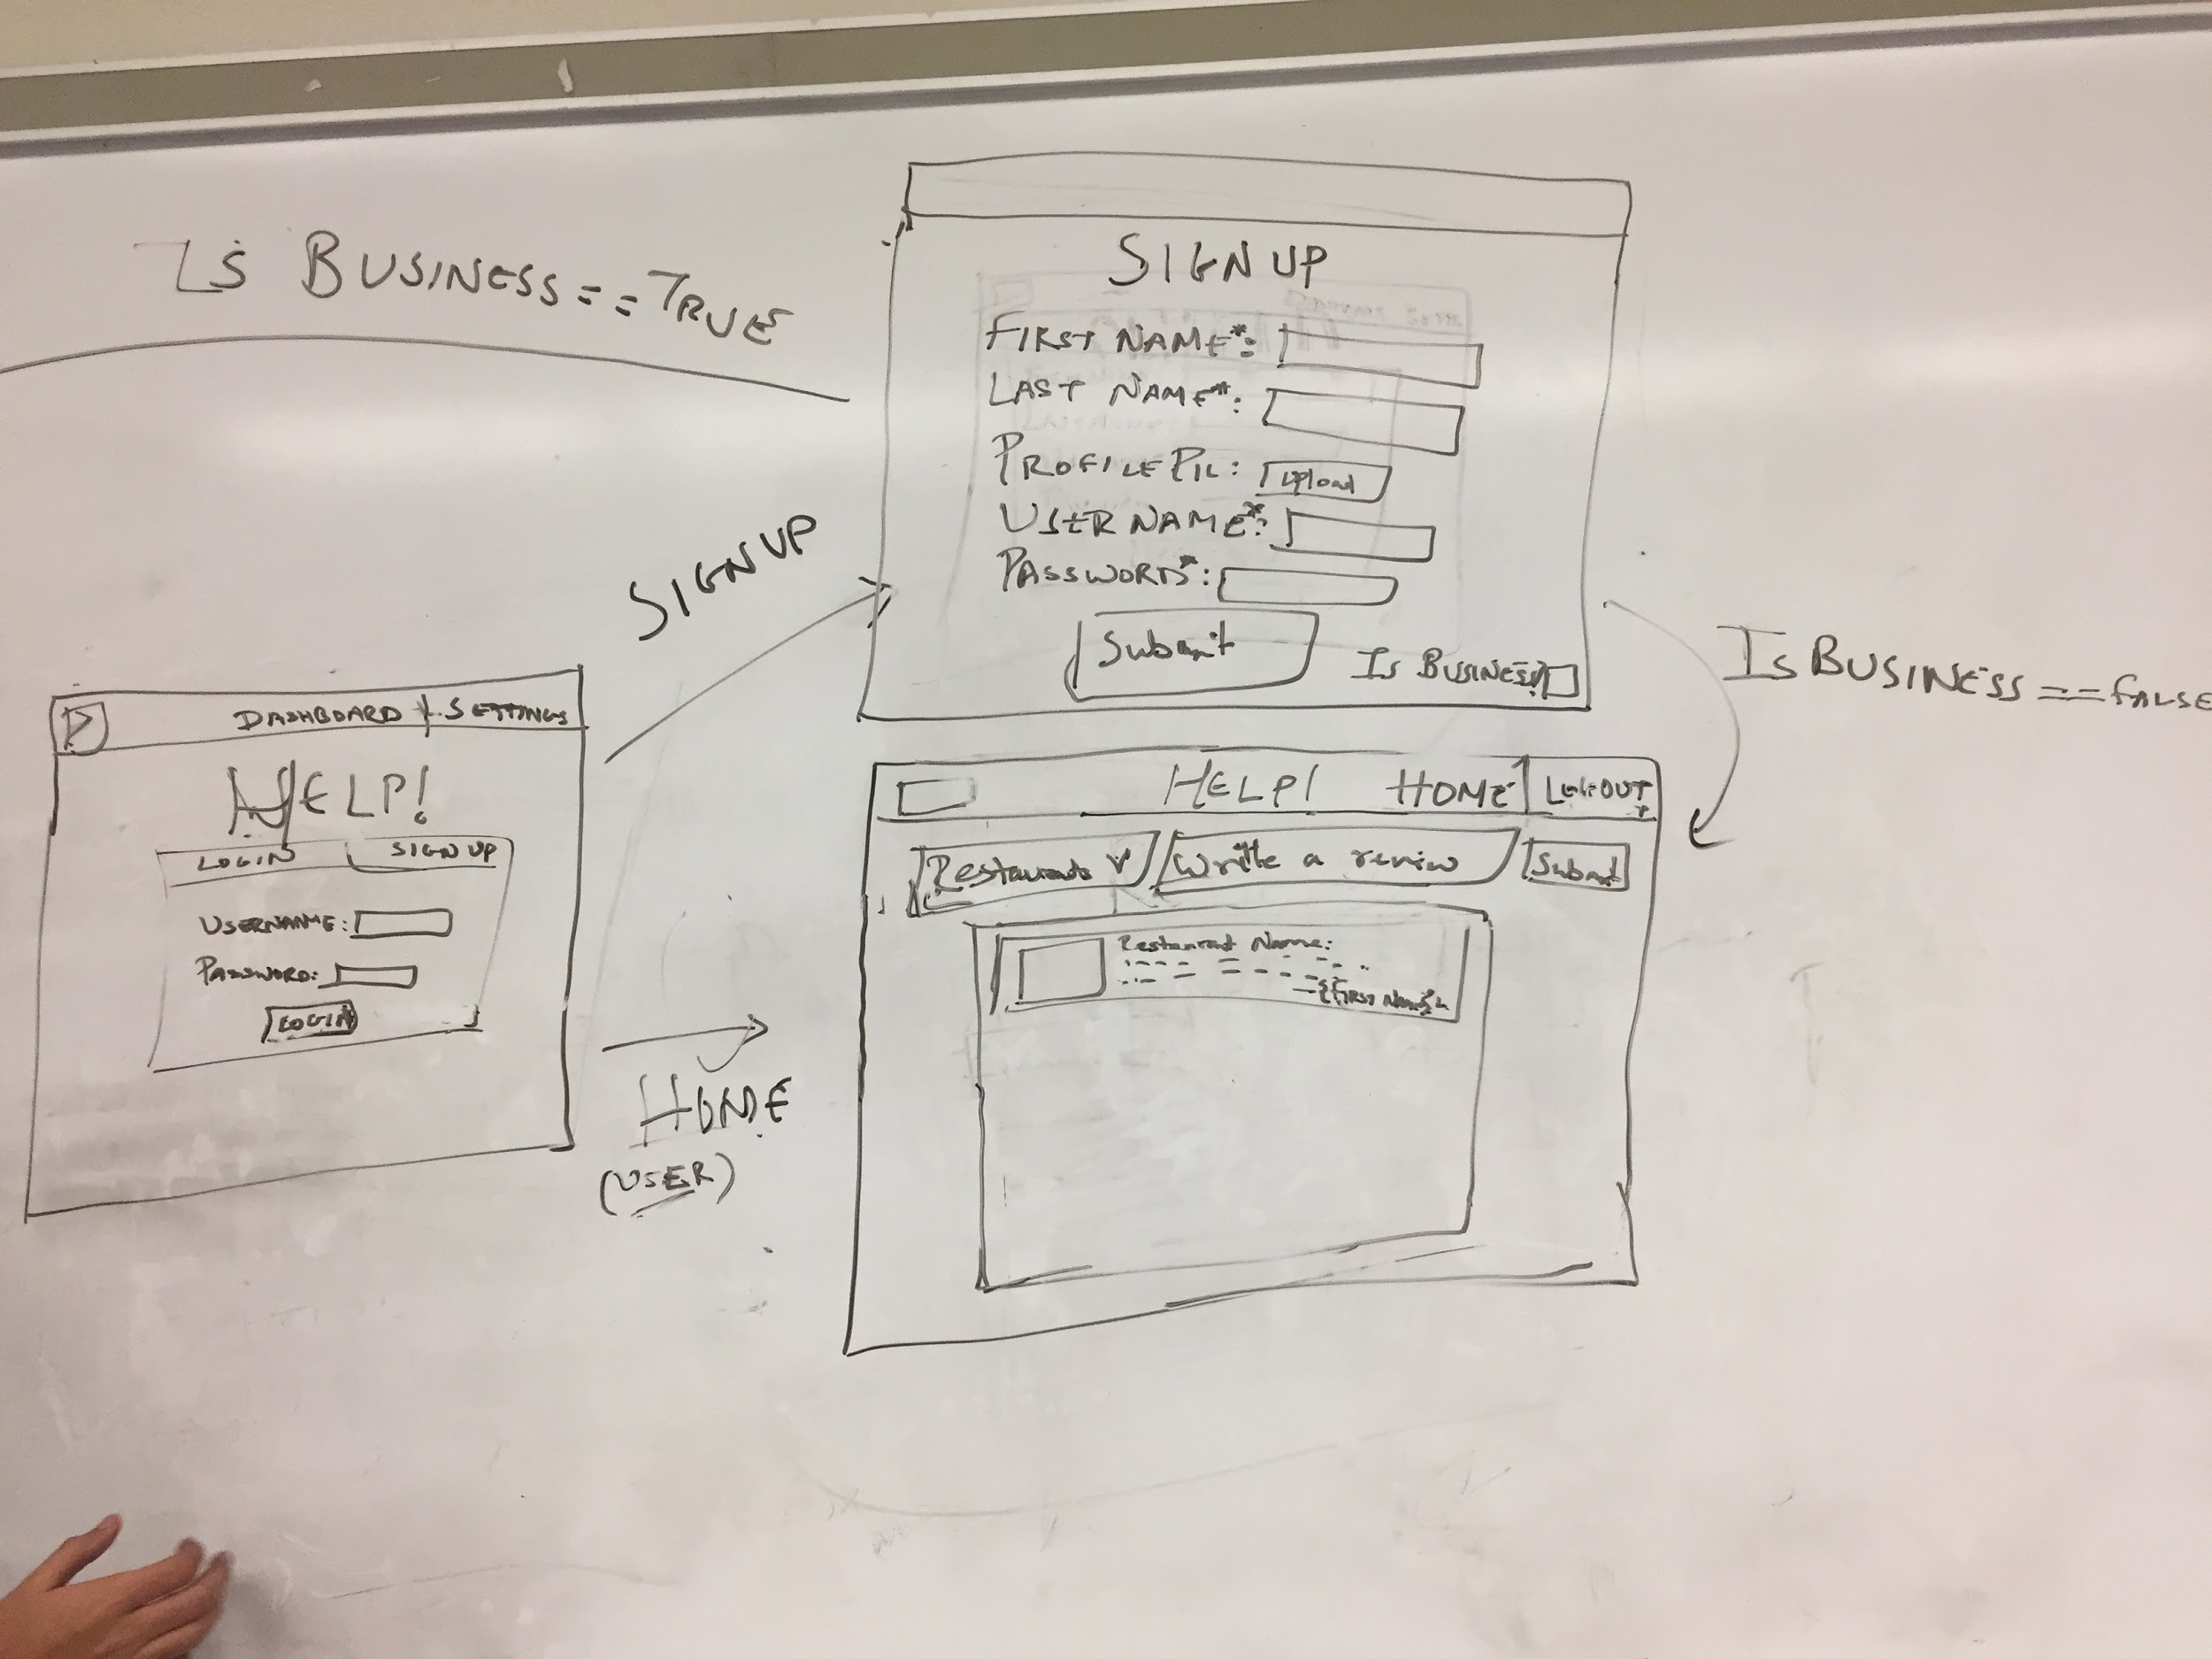

**A user will either login or signup. During signup, the user will have the option to set the account as a business account or a regular account.**

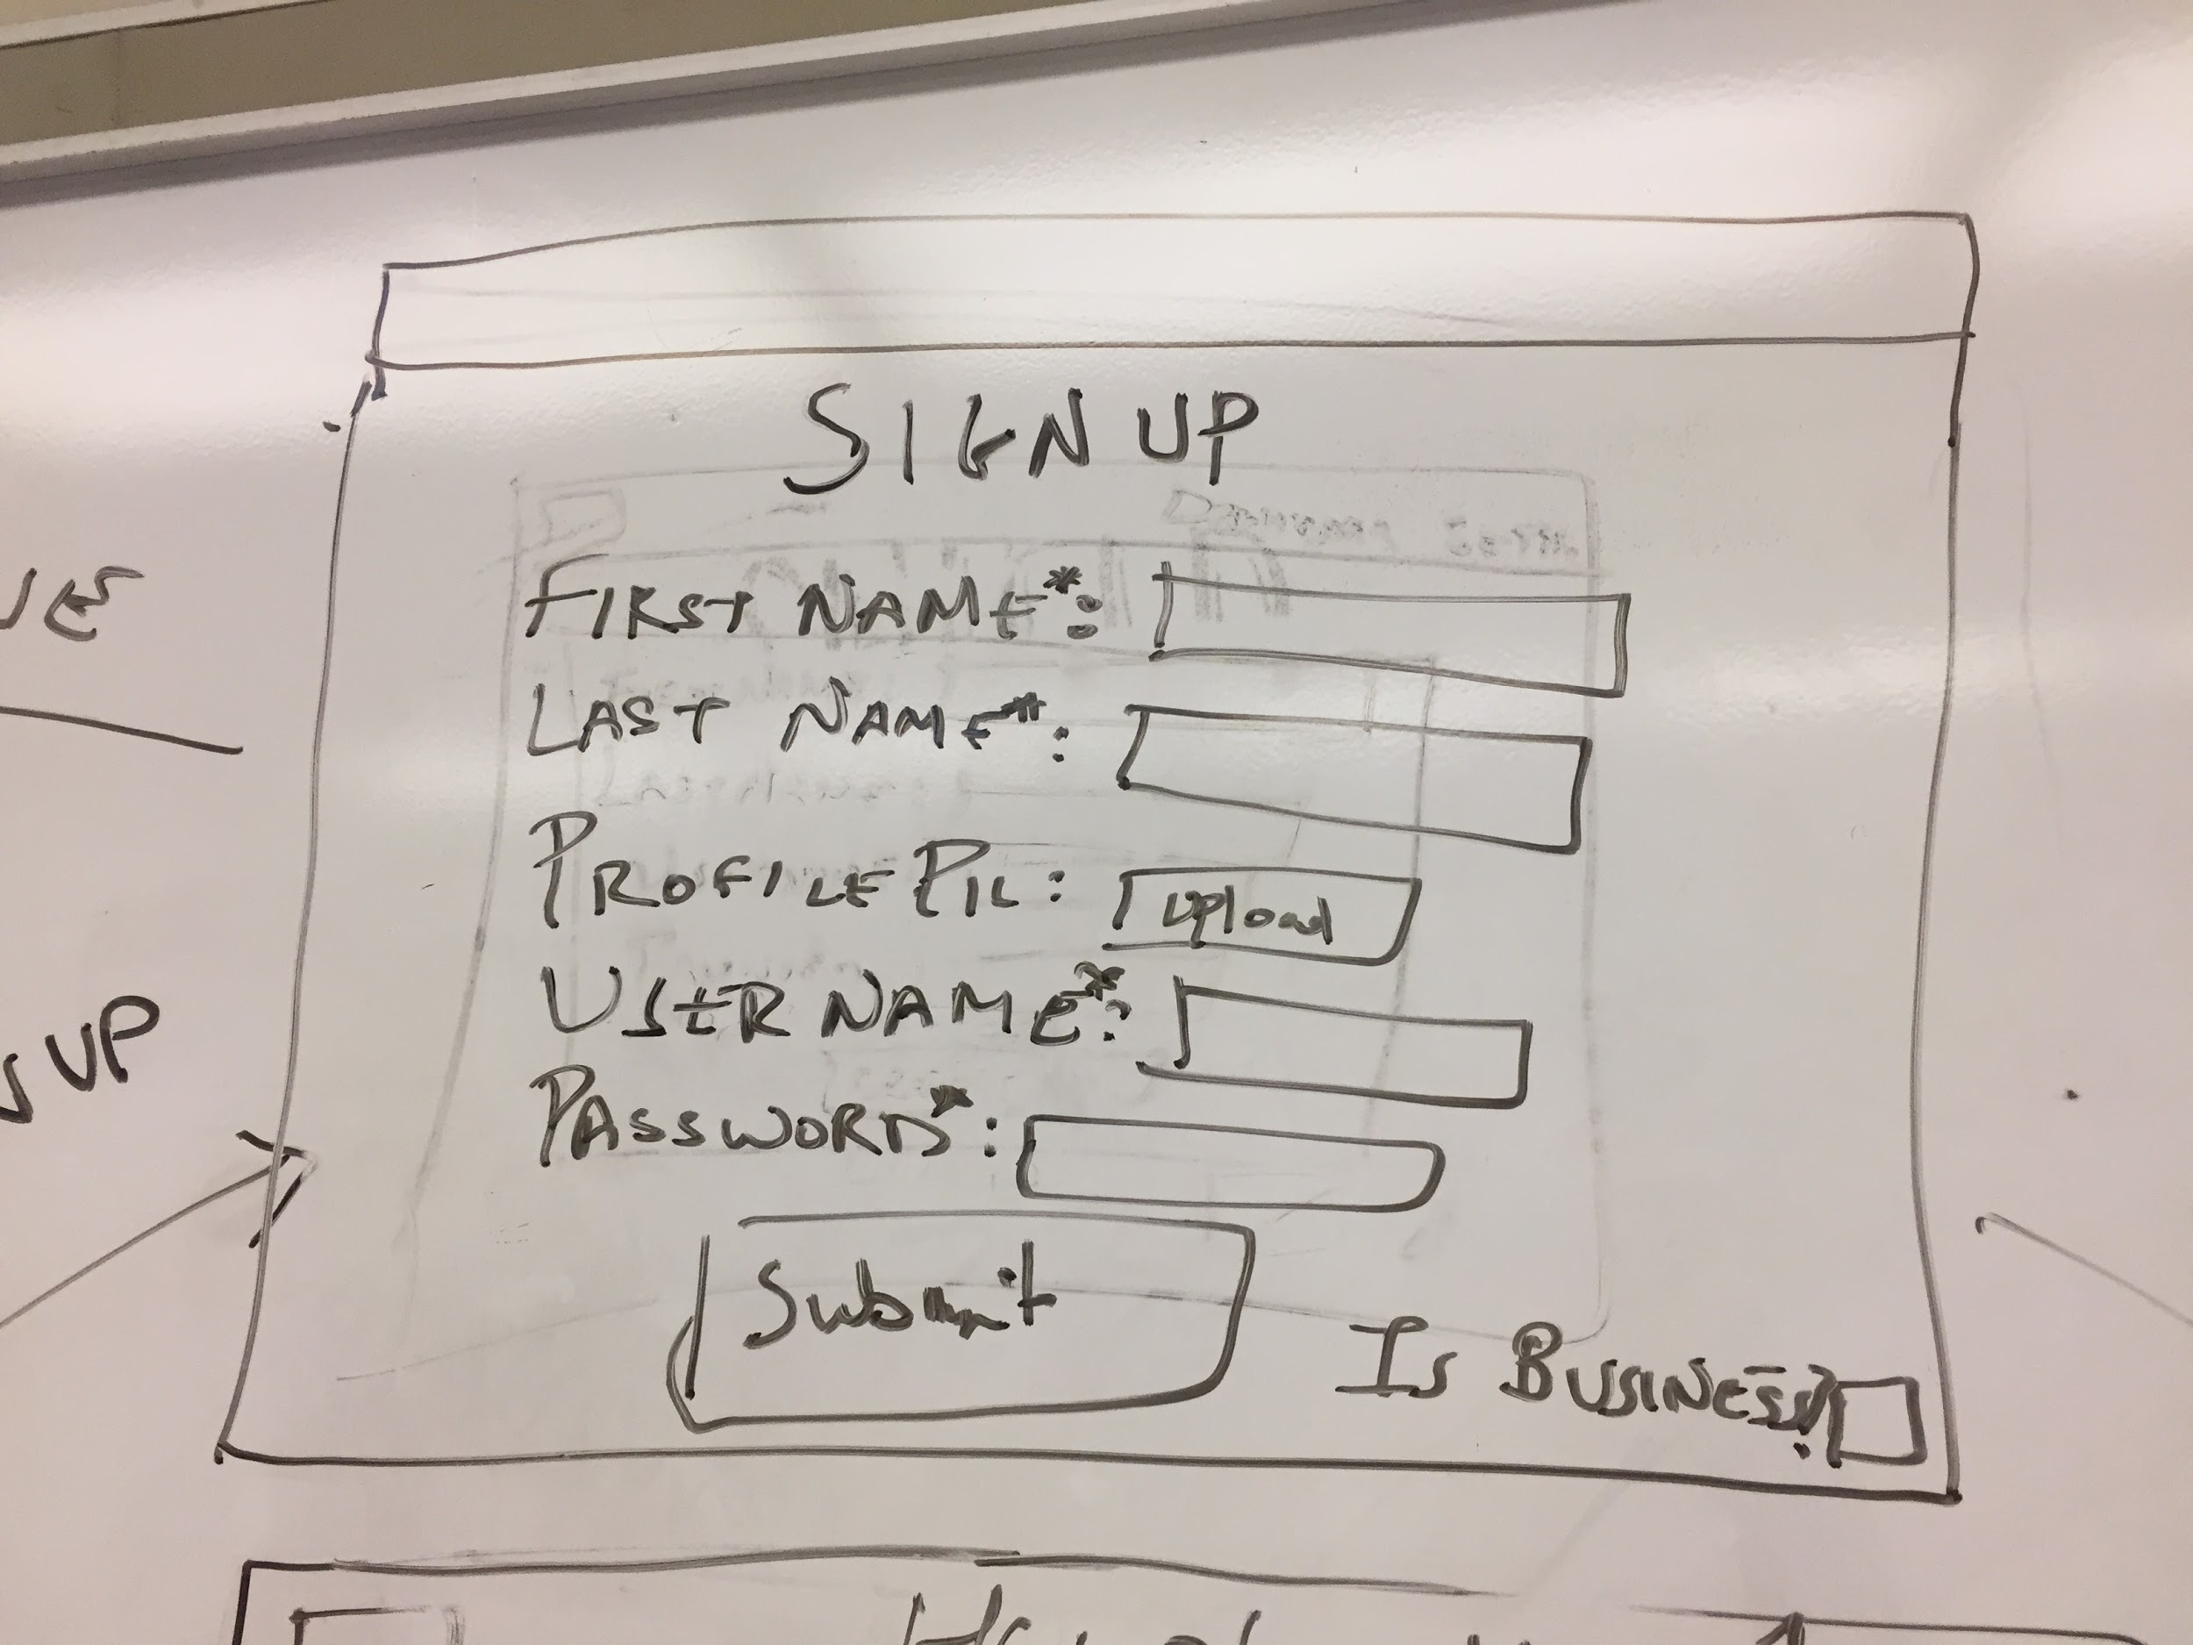

**The signup will have the form for all information of the user / business account. On checking the “Is Business” checkbox, the user will be routed to the appropriate components.**

**The user (Non business account) will see the home page, which will have a “write a review” text box at the top and drop down containing all the restaurants. The user can submit as well as take a look at all the reviews. New reviews will be added at the top of the container.**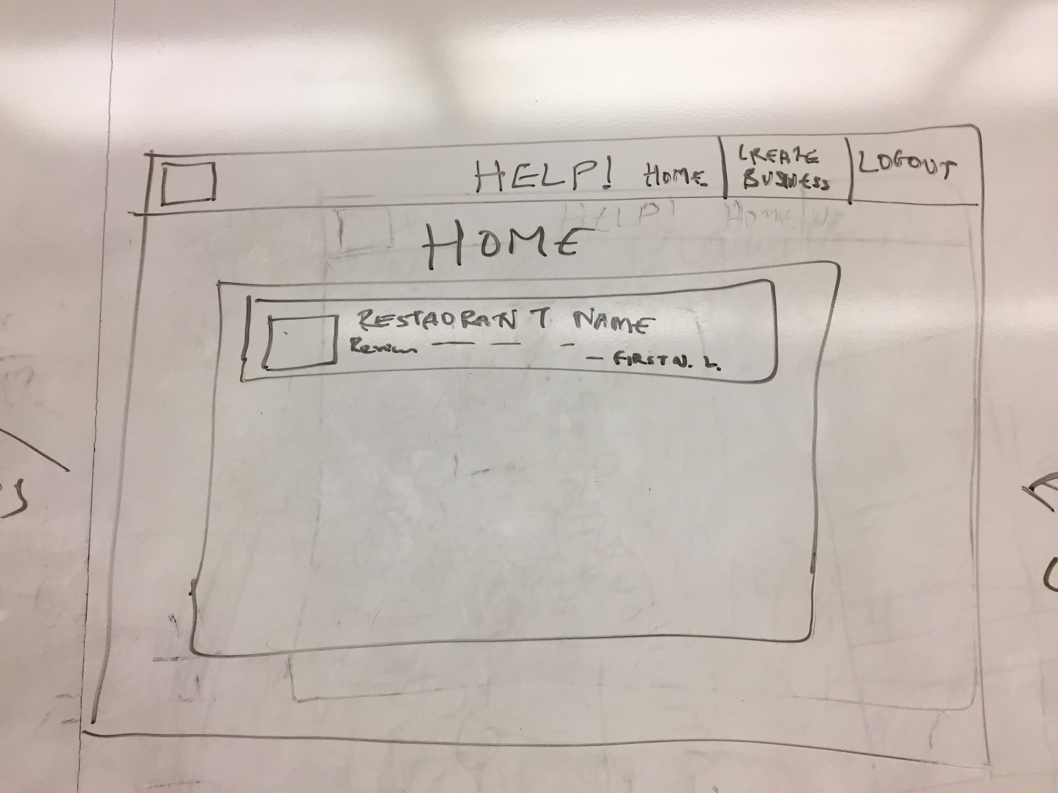

**The business account will see the reviews for the restaurants he created. He will also have the option to create a new business. The business account wont be able to write a review.**

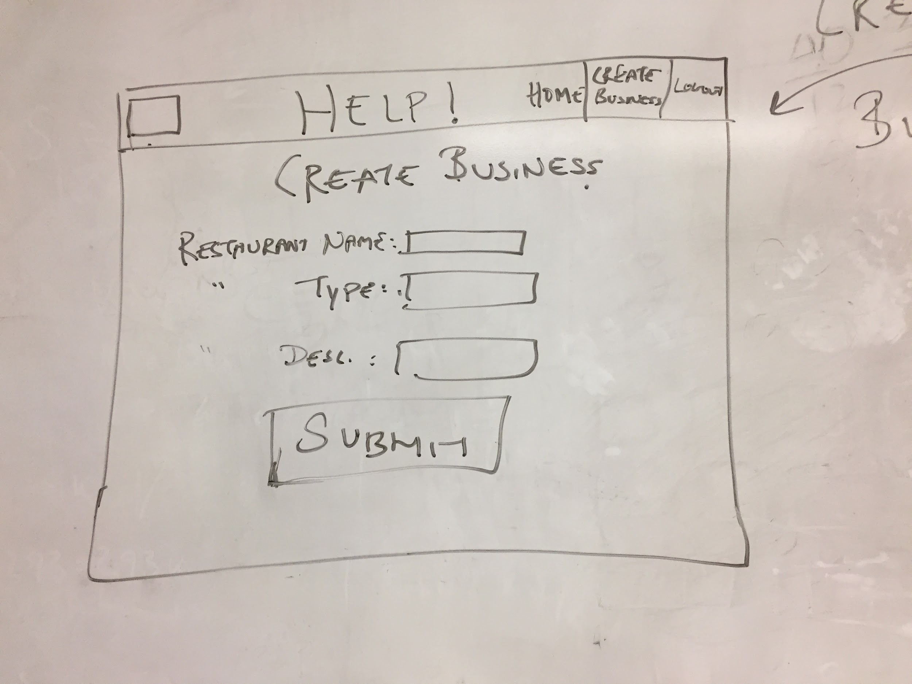

**The actual userflow of the application.**